Nexora sales and finance
Document 15 of the Nexora learning guides
Source snapshot 14 October 2026 at 06:41 UTC
Understand catalogue products, orders, invoices, receipts, allocations and reconciliation.

Recognise the screen and its scope
Open /finance/catalogue, /finance/orders, /finance/invoices, /finance/receipts. CRM routes use port 3017; member routes use 3018; public website routes can use 3019. Brackets name a route parameter, not text to paste into a browser. Choose a real record or site id from the application.
This guide covers Catalogue and currencies; Order lines and posting; Invoices and credits; Receipts and refunds; Allocations and reversals; Reconciliation export and history.
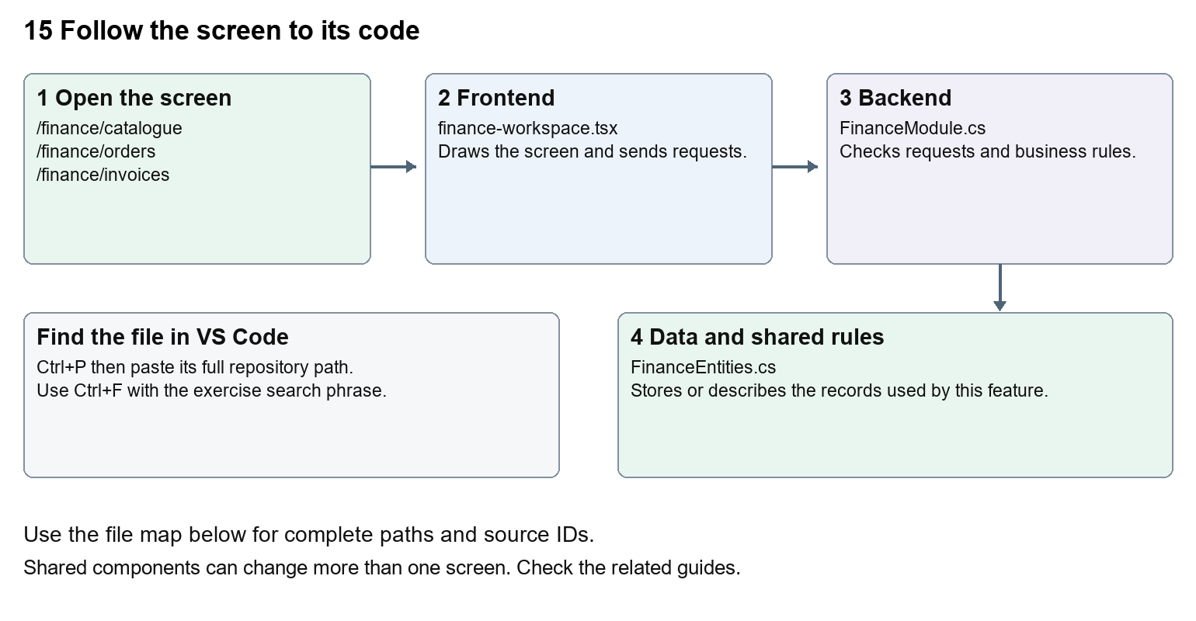
The diagram shows the file roles. The full paths below are what you paste into Ctrl+P.

Find the files in VS Code
Role | File and source ID | What it does
Screen | S0098 finance-workspace.tsx | Main UI or route for this topic
Server | S0349 FinanceModule.cs | Endpoints or server rules
Data | S0348 FinanceEntities.cs | Data shape or persistence structure

Screen S0098
apps/web/src/features/finance/finance-workspace.tsx
Server S0349
backend/src/Modules/Nexora.Modules.Finance/FinanceModule.cs
Data S0348
backend/src/Modules/Nexora.Modules.Finance/Domain/FinanceEntities.cs
The complete HTML manual opens these source IDs inside its Source library. The Word manual shows short labelled extracts so you can learn the flow before reading large files. Each individual Markdown guide includes its complete primary files after the walkthrough.

Follow the request and the records
1. A catalogue product supplies price, currency and VAT basis points.
2. An order holds customer and line items.
3. Posting produces a stored invoice using validated totals.
4. An external receipt is recorded separately.
5. Allocations link available receipt money to invoice balances, with reversals and reconciliation history.

Read the code with an explanation
The frontend displays actions but the backend calculates financial balances and validates amounts. A posted invoice is a stored accounting record. Recording a receipt explicitly does not initiate a charge. Credits reduce invoices; refunds reduce available receipts; allocations connect the two. Keep those meanings separate when tracing request fields.
Source reference S0098 apps/web/src/features/finance/finance-workspace.tsx
Selected opening lines with their original numbers. The complete file is in the HTML source library.
0001 "use client";
0002 import listingStyles from "../crm/record-listing.module.css";
0003 import { WorkspaceHeading } from "@/components/ui/workspace-heading";
0004 import { RecordListing, useRecordPage } from "../shared/record-listing";
0005 import { Plus, ArrowLeft } from "lucide-react";
0006 import { useRouter } from "next/navigation";

The import lines lead to shared components and helpers. Start at the exported component or route function; follow the request helper to the server rather than assuming the whole feature lives in this file.
Source reference S0349 backend/src/Modules/Nexora.Modules.Finance/FinanceModule.cs
Extract from source line 31. A fragment from a long line is shown without the rest of that line.
0031 api.MapGet("/customers",(string? search,ICrmDirectory crm,CancellationToken ct)=>crm.SearchContactsAsync(search,ct));

On the server, look for MapGet to load records, MapPost to create or perform an action, MapPut or MapPatch to change data, and RequireAuthorization for permissions. Some shared methods register endpoints indirectly. Find SaveChangesAsync to see the database write. A request method alone does not tell you every side effect.
Source reference S0348 backend/src/Modules/Nexora.Modules.Finance/Domain/FinanceEntities.cs
Selected opening lines with their original numbers. The complete file is in the HTML source library.
0001 using Nexora.BuildingBlocks.Domain;
0002 namespace Nexora.Modules.Finance.Domain;
0003 public sealed class CatalogueProduct:TenantEntity
0004 {
0006 }
0007 public sealed class SalesOrder:TenantEntity

Follow model fields to their request names and database mapping. An id points to a particular record. A tenant id limits the organisation. A version or concurrency stamp protects newer edits. Some model files describe contracts rather than tables; check the owning DbContext before assuming storage.

Make or trace your first change
1. Press Ctrl+P and open apps/web/src/features/finance/finance-workspace.tsx.
2. Press Ctrl+F and search for export function. In this snapshot it appears at line 13.
3. Read-only exercise: find the workspace export and trace the receipts create request to FinanceModule. Find the server history message saying no charge was initiated. Explain why a receipt form is different from taking a card payment.
4. Record the file, request path and server handler you found. This exercise is read-only; no stored records need to change.
Extract from source line 13. A fragment from a long line is shown without the rest of that line.
0013 export function FinanceWorkspace({permissions, section = "orders"}:{permissions:string[]; section?: string}){

These exercises have not been applied to the application. Their search phrases are verified against the captured source. Line numbers can move; the phrase and file path are your main navigation aids.

Check a change and diagnose problems
Confirm the original screen still loads, the changed words appear in the intended place, and another screen using the same component still behaves correctly. If an action fails, inspect the browser Network response, the relevant helper and server validation message. Use the common error table at the beginning of the manual. Reload on a version conflict instead of removing the version check.
A syntax error after a text edit usually means a quote, brace or closing tag changed. Compare your diff with the original. An unchanged browser result can mean the wrong port, a saved published configuration overriding a default, or a running API that has not reloaded.

Understand the current limits
No live payment processor or statutory accounting acceptance is established by these records. Calculation, posting and currency changes require targeted financial tests; beginners should start with text-only exercises.

Continue learning
Related guides 09 Nexora member records and subscriptions, 11 Nexora membership setup and products, 16 Nexora engagement and fundraising, 19 Nexora insights and reporting.

